 | 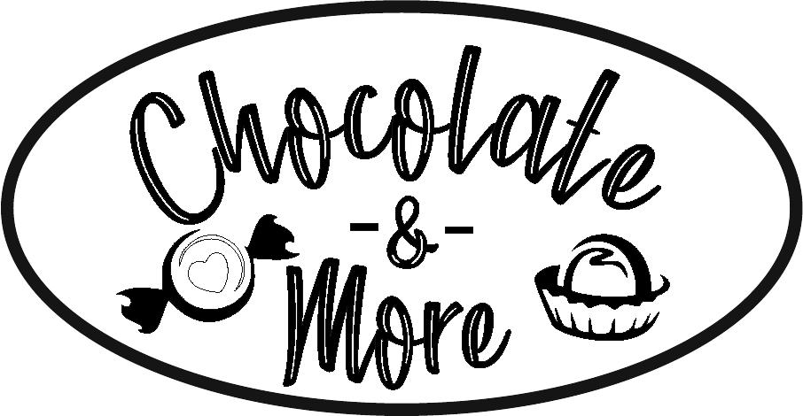Sponsor Form  Saturday, April 12, 2025, 1:00pm – 4:00pm  NEW LOCATION: Ashland Middle School.  Our 13th Annual Event will Celebrate the Sweetness of the Ashland Area as we invite the public to sample chocolates and other unique treats created by local businesses/groups; all in the name of supporting the mission of ACHC “ to provide high quality compassionate health care for those who cannot afford it.”

Sponsor Information (please print)

Company Name
As it should appear in ads

Contact Name

Billing address

Phone Number

Email/Fax

Sponsorship Opportunities: includes event sign, advertising acknowledgement, & 2 general admission passes for event. Contributors donating any amount will also be acknowledged.
Welcome Area | $200
Tote Bag Sponsor 2 available | $200
Wellness Station | $200
EGG Hunt Treasure Grab | $250 --purchase a plastic egg for $10, and win a gift card of higher value
Raffle Basket Area | $250
Raffle Basket Donation | $75 toward a themed Raffle Basket, OR  A COMPLETED Raffle Basket or Item
Total Sponsorship Amount $____________________

Signature(s) |  | Date
 |  | Please make checks payable to:
Questions?  Contact Cheryl Benway , Executive Director  419-903-0475 cheryl@achcoh.org |  | Ashland Christian Health Center  380 E. Fourth Street  Ashland, Ohio 44805

